

SCHOOL OF COMPUTER SCIENCE ENGINEERING | MRCET
(CSE)
Email: mrcetcse2004@gmail.com
II Year B.Tech-II Semester IOP Individual Summery Sheet
Project Title:
Project Code: |  | R24A0590 |  |  | Batch Size: | 3 |  | Batch: |  | 2024-28
Domain / Area: |  | Healthcare and Information Technology |  |  |  | SDG Mapping |  |  | 3
Abstract:

Technical (S/w & H/w) Specifications |  |  |  | Module(s) Specifications
Architecture Diagram |  |  |  | Methodology
Existing System |  |  |  | Proposed System
Guide Details |  |  | Batch Members Details
 |  |  | M. Aditi Madhumitha |  | Kethavath Ragya Naik |  | Mangalapally Vennela

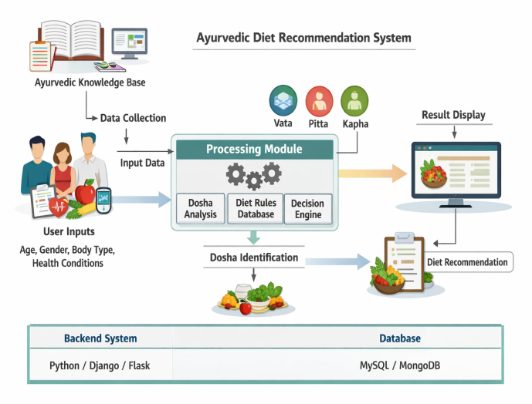
The Ayurvedic Diet Planner was developed by first identifying and analyzing the system requirements to provide diet recommendations based on user health conditions. Based on this, the system design and UML diagrams were created to understand the workflow and structure clearly. The application was then implemented using Python Flask for backend processing and HTML/CSS for designing the user interface. SQLite database was used to store user and patient details. The system accepts user inputs, validates them, calculates BMI, and generates suitable diet recommendations. Finally, the application was tested to ensure proper functionality, and necessary improvements were made.

- A web application that automates Ayurvedic diet recommendations.
- Users enter health information through a digital form.
- The system calculates BMI and suggests diet automatically.
- Patient data is stored in a database.

Patient records are maintained using paper files.

Diet suggestions are given manually by dieticians.

Managing large patient records is difficult.

Paper records can be lost or damaged.

1.Computer/Laptop with minimum 4 GB RAM and i3 processor
2.500 GB storage with keyboard and mouse
3.Python with Flask for backend
4.HTML and CSS for frontend
5.SQLite database and web browser

AYURVEDIC DIET PLANNER
The Ayurvedic Diet Recommendation System is a web-based application developed to provide personalized diet suggestions based on a user’s health information. The system collects basic details such as name, age, height, weight, and selected health issues, and then calculates the user’s Body Mass Index (BMI) to determine their health category. Based on this information, the application recommends suitable Ayurvedic food items and suggests foods that should be avoided for better health management. The system is developed using Python with the Flask framework, along with HTML and CSS for the user interface, and SQLite database to store patient details and health records. The main goal of this application is to promote healthier dietary habits using Ayurvedic principles while providing a simple, efficient, and user-friendly platform for users.

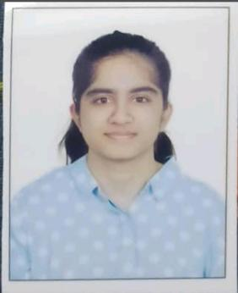

Student Photo
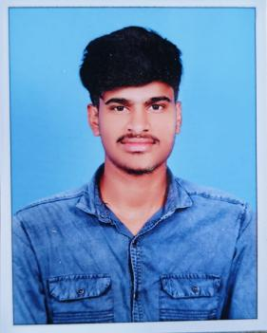

Student Photo
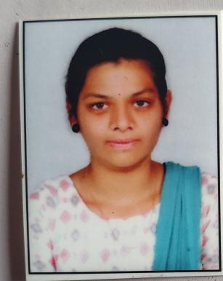

Student Photo
21N31A05Q5

Student Photo
21N31A05L0

Student Photo
21N31A05Q6

Student Photo
Ms. S.J. Shruthi Yadav
Assistant Professor
Dept. of CSE
MRCET
Campus
UGC Autonomous
Institution-Govt. of India
Hyderabad
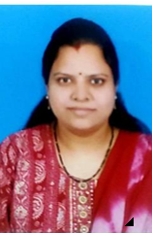

Guide Photo

User Input: User details.
Processing: Analyses the input data.
Output: gives BMI and recommends right diet.

